**Converting the component into page and to open it at a specific URL is called “routing”**

**To install: run the command 🡪 ‘npm install react-router-dom’.**

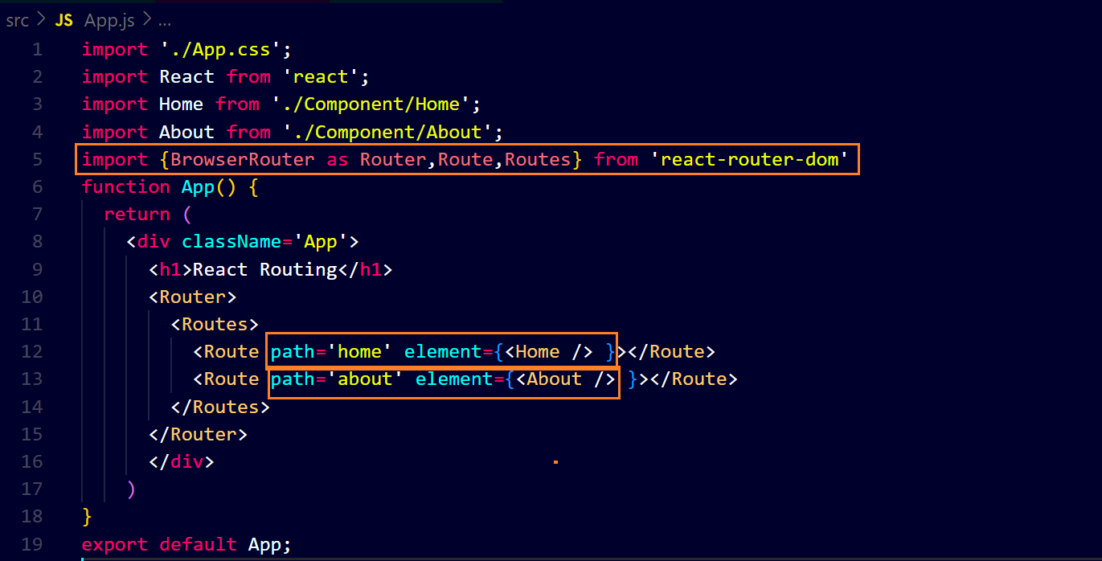

**For home page ↓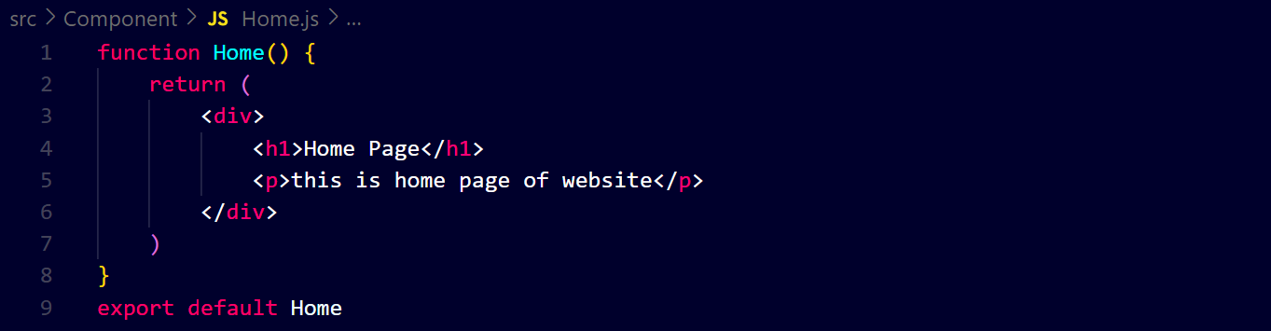output ↓**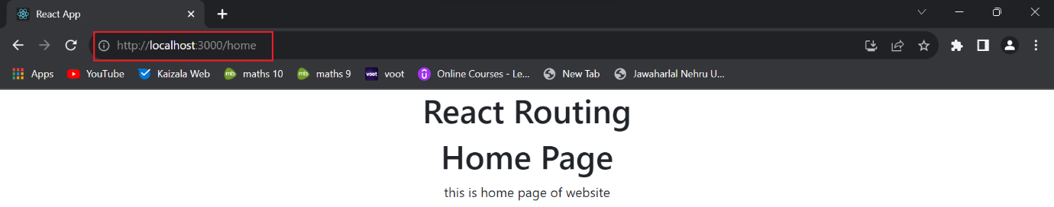

**For about page ↓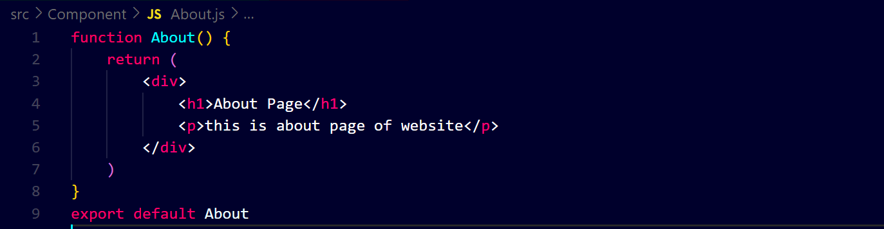output ↓**